

**Assignment #3**

# **Instructions:**

**Be sure to read the following general instructions carefully:**

* This Assignment should be completed individually by all the students.
* You must submit the following in the assignment **drop box**:
  1. Zipped folder containing all your *.html files
* Grade Rubrics:
  1. Code compiles, runs and provides the expected output 30%
  2. Code Structure & Design 60%
* You might be asked to demo your solutions in-person.
* **100%** of your mark could be based on your **in-person demo of the solution**.

**Academic Integrity**

* **PLAGIARISM** is an Academic Offence
* Doesn't help you learn the course material
* Giant waste of your time and mine
* Causes mark penalties and transcript annotations

1. Create an html page with a table that displays as follows – same look and feel:

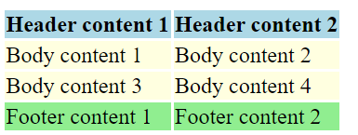

1. For creating the table as displayed above, your solution should make use of the following tags:
   1. thead
   2. tr
   3. tfoot
   4. tbody
   5. tr
2. The table head rows should contain the following content as displayed in the image above – each should be a separate cell:
   1. Header Content 1
   2. Header Content 2
3. The table footer rows should contain the following content as displayed in the image above - each should be a separate cell:
   1. Footer Content 1
   2. Footer Content 2
4. The table body should contain the following elements as displayed in the image above - each should be a separate cell:
   1. Body Content 1
   2. Body Content 2
   3. Body Content 3
   4. Body Content 4